The instructions to access the webinars presented at our training session, made an inaccurate assumption. That being that you had already enrolled in the session, which I had done. So if you are enrolling for the first time, which I anticipate you all are, follow the instructions below to enroll for the first time

Sorry for confusion.

For your annual re-certification training, go to Uslacrosse.org:

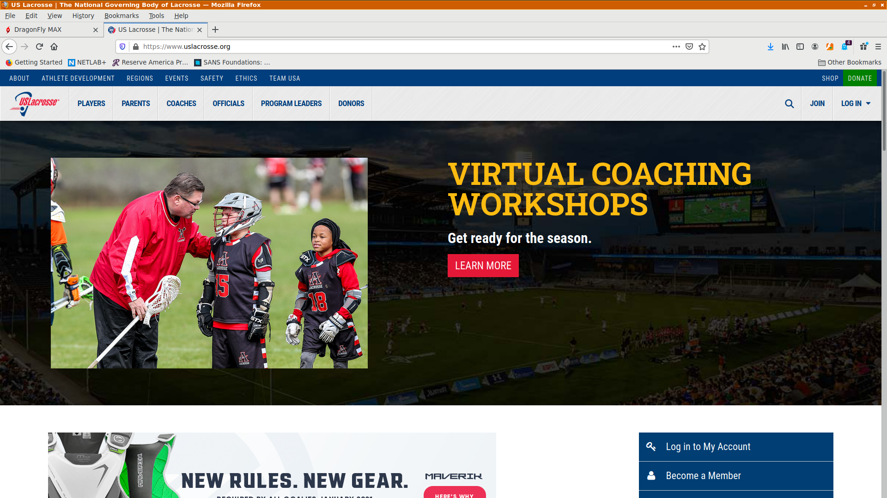

Once logged in, click on the 3 bars in the red box in the upper left corner:

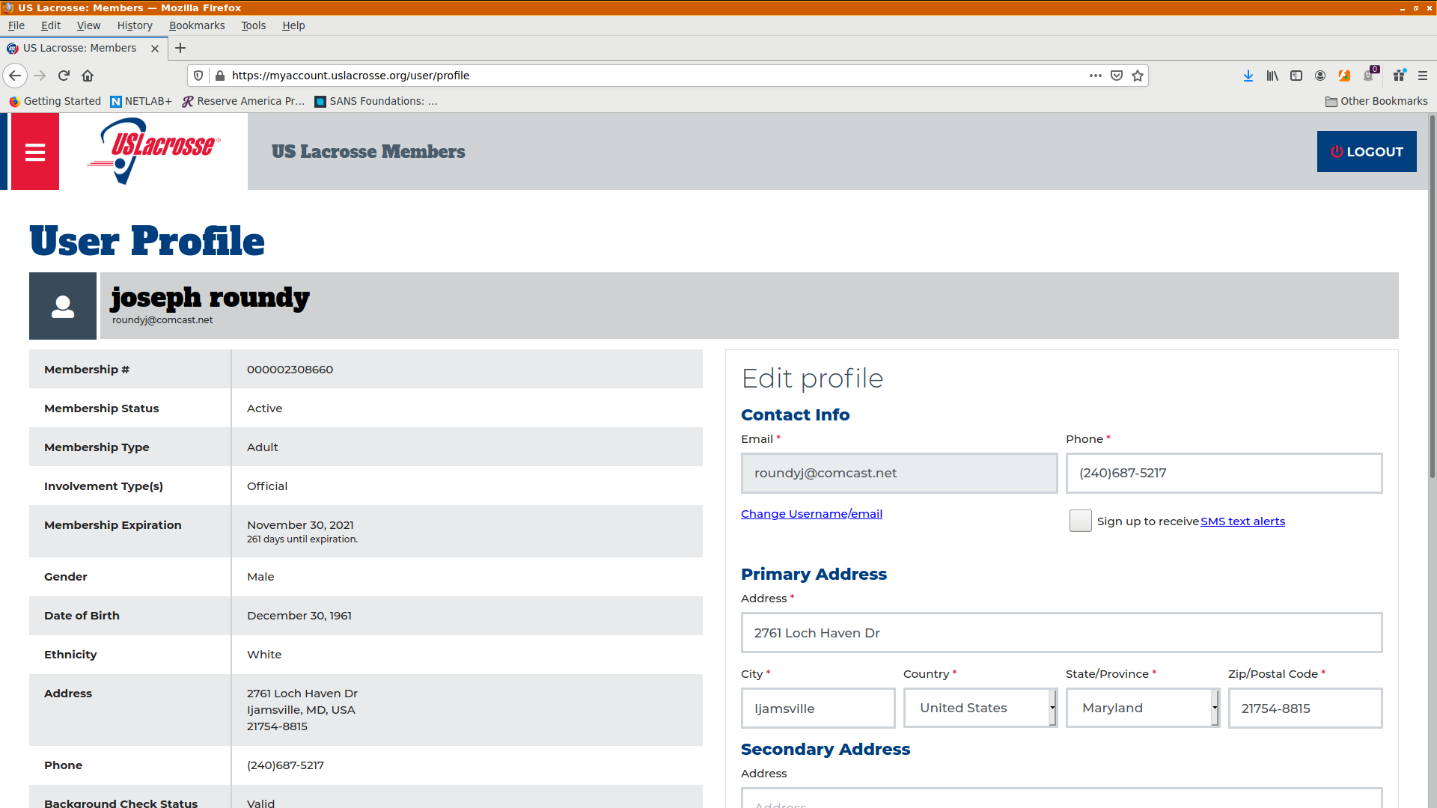

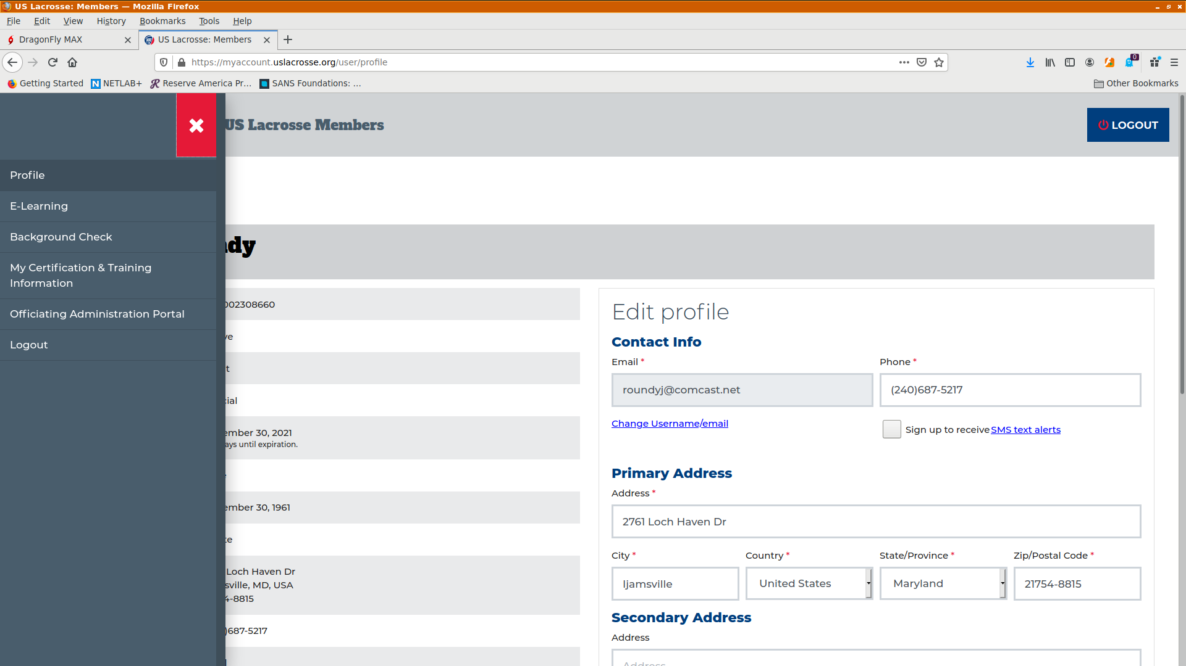

Select “E-learning”:

Select “Catalogue”:

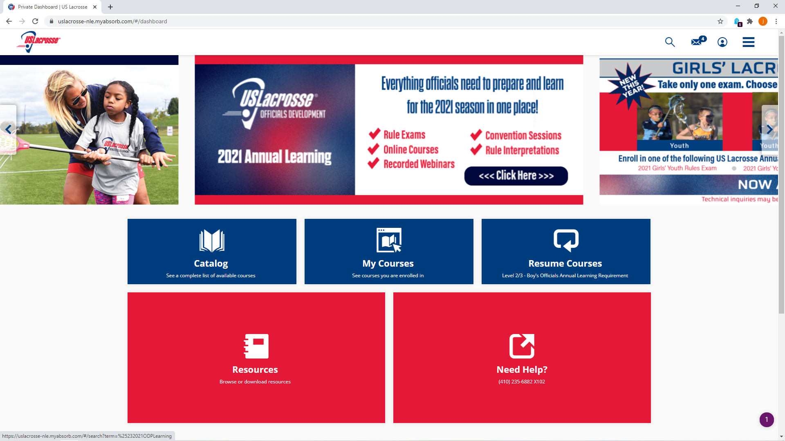

Select “Officials”

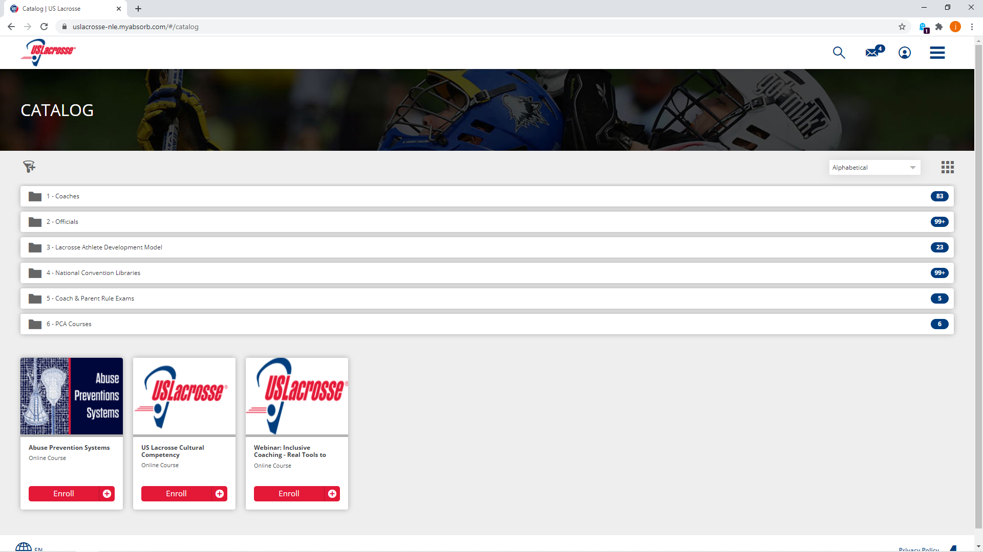

Select “Men’s Game Officials”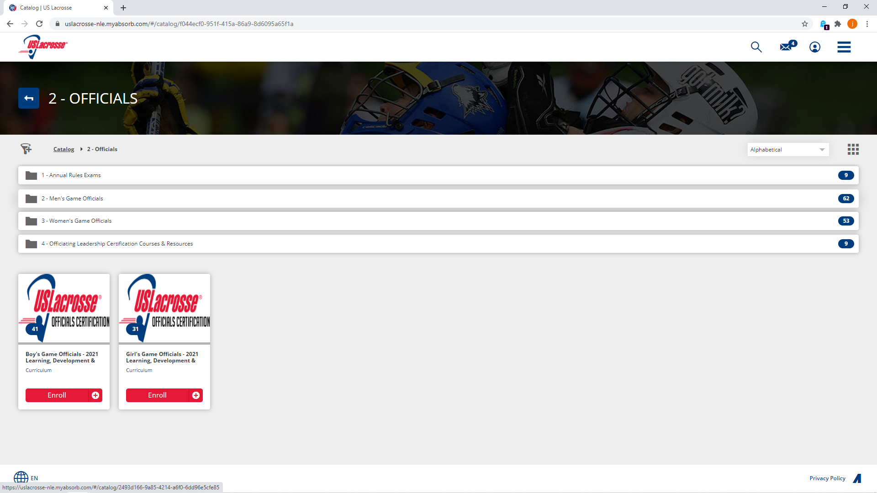

Select “Professional Development Webinars”:

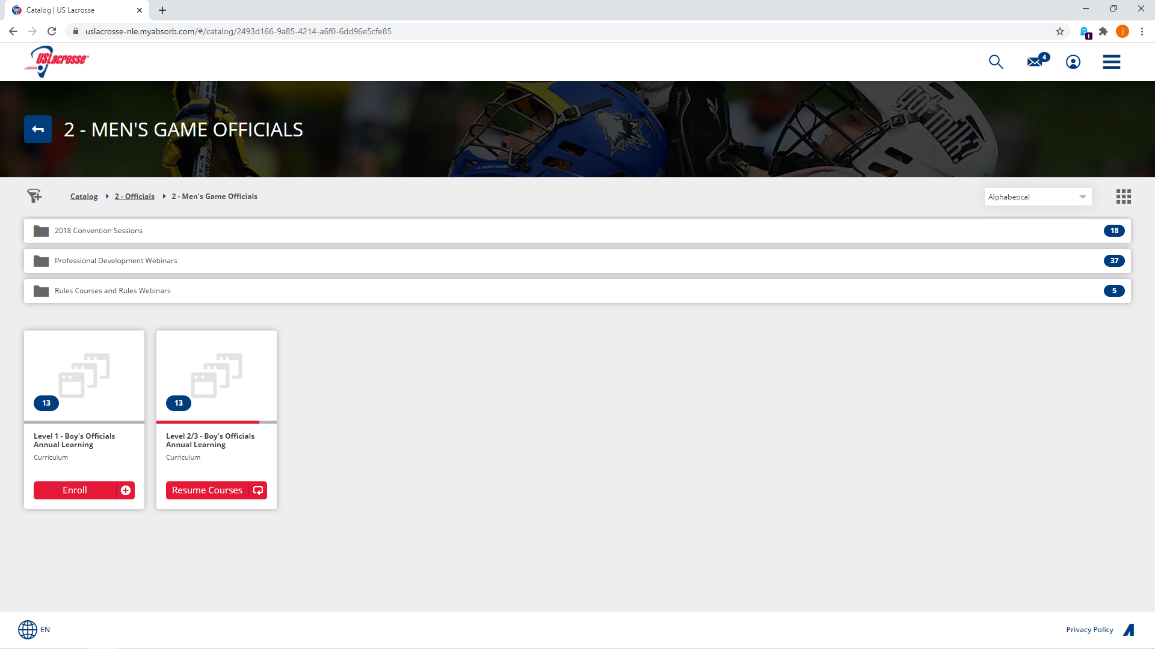

At this point you should see “Level2/3 – Boys Officials Annual Learning Requirement”. If you do not, search through the USLax site to fine this course. Once you enroll, you will have access to the training webinars mentioned in our training session.

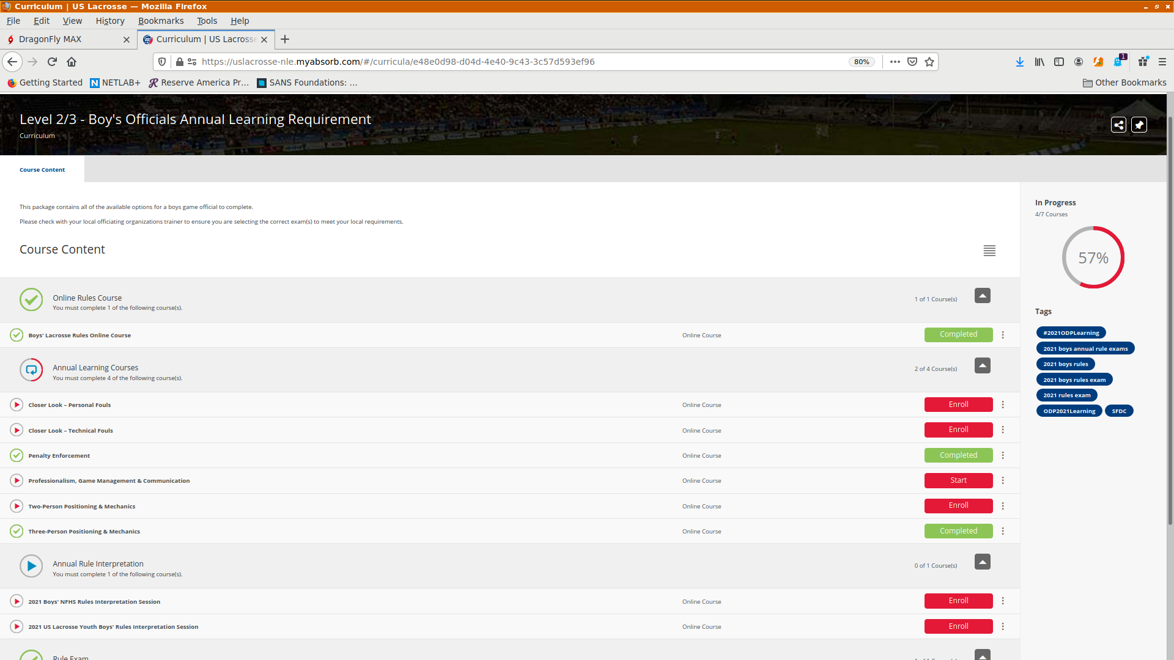

As well as the “Rules Exams”

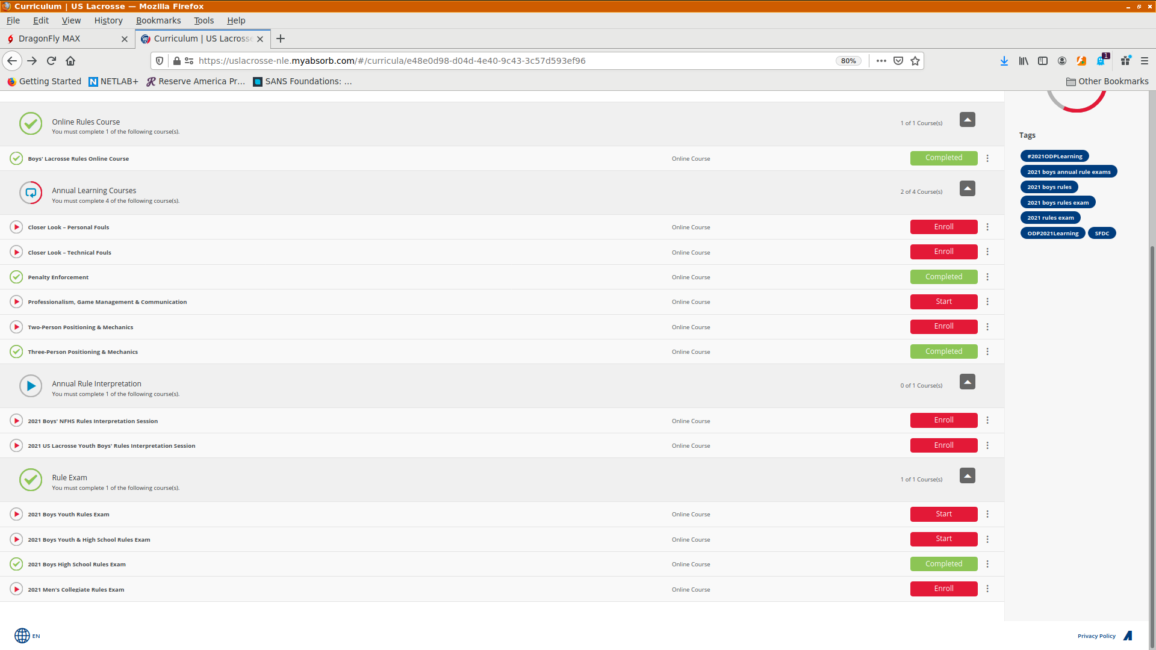

One of the USL exams is required to remain a USL member in good standing for 2021. The 2021 Boys High School Rules Exam is 50 questions, not 100 as with the MPSSAA exam.

You are to complete 4 of the “Annual Learning Courses”, one of which MUST be the “Professionalism, Game Management & Communication” module. We encourage you to take “Closer Look – Personal Fouls”, “Closer Look – Technical Fouls” and “Penalty Enforcement” as the other three.

If you are new to or need a refresher on the 3-man mechanics, enroll in and take the “Three-Person Position & Mechanics” module.

Upon completion, either send me ([roundyj@omcast.net](mailto:roundyj@omcast.net)) a copy of the certificate:

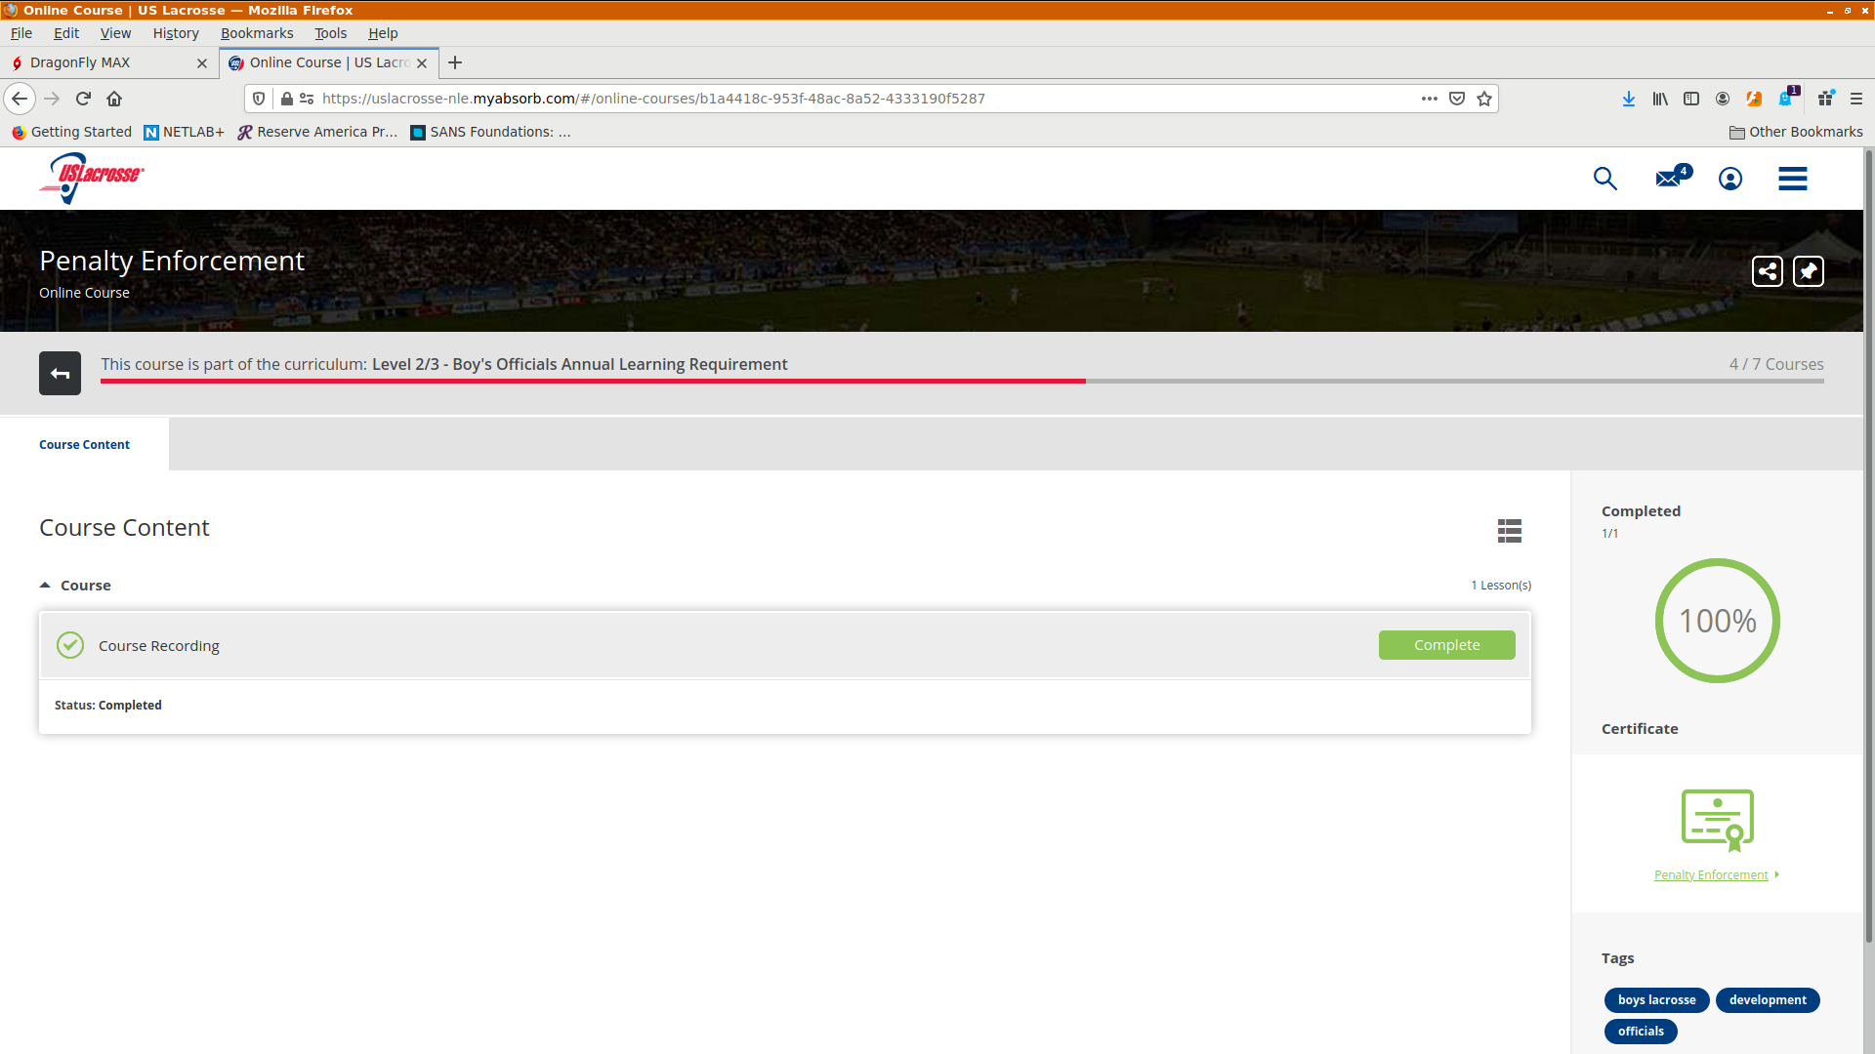

Or a screen shot showing all courses have been completed:

